Index

* Index---------------------------------1
* Login---------------------------------2
* Tare Weight/Check-in Entry--------- 3,4,5
* Cash Entry--------------------------6
* Internal Vehicle Entry-----------6
* Gross Weight/Check-out Entry-------7,8
* Update Entry----------------------9
* To Cancel Inside Mines Vehicle-------10
* Internal Vehicle Tare Weight Update-------11
* To Check Inside Mines Vehicle ----------------12

**Login**

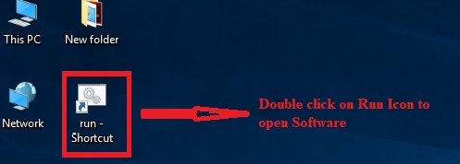

**Fill the User ID Provided by the IT Department**

**Example for - User ID – MSK123 & Password – M@123**

**Then Click login button**

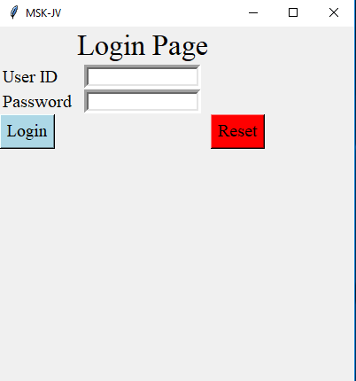

**Tare Weight/Check-in Entry**

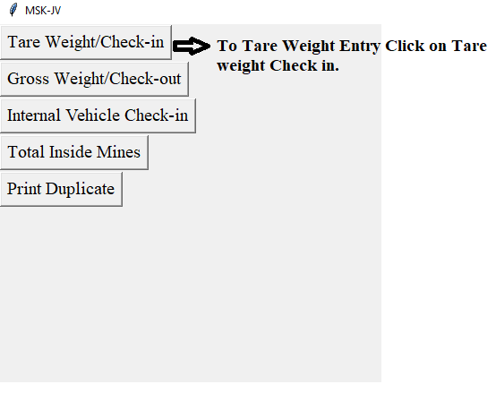

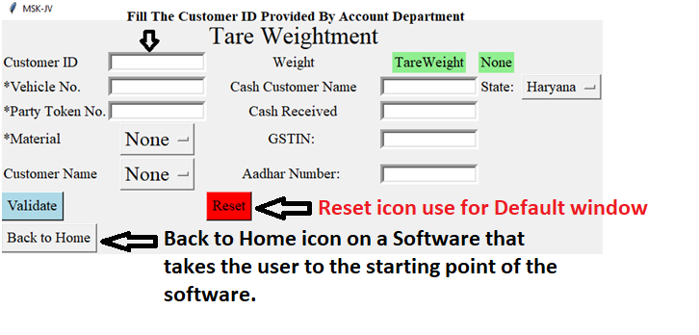

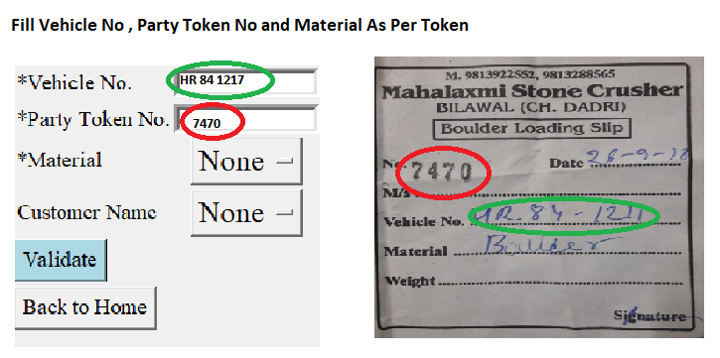

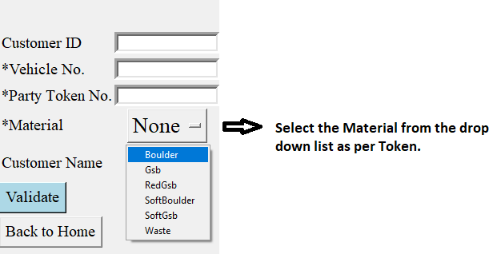

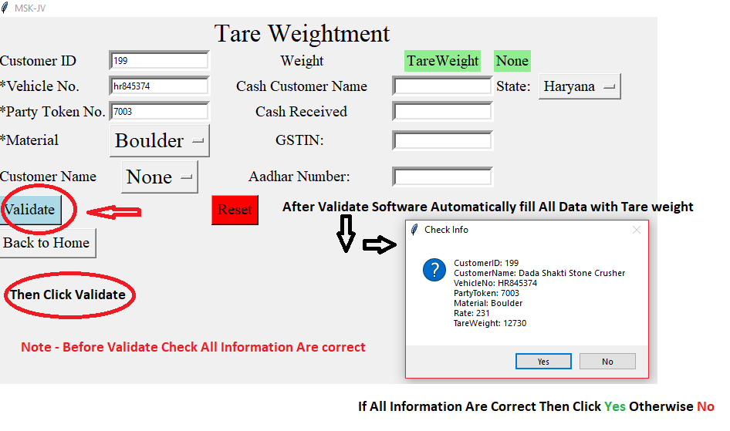

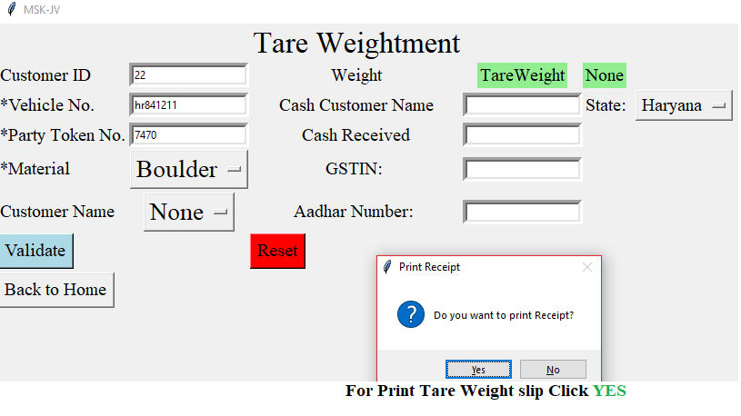

**Tare Weight Entry Complete**

**Cash Entry**

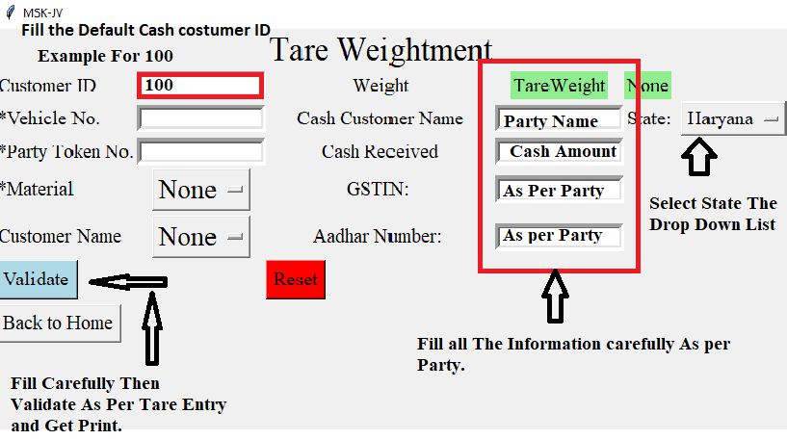

**Internal Vehicle Entry**

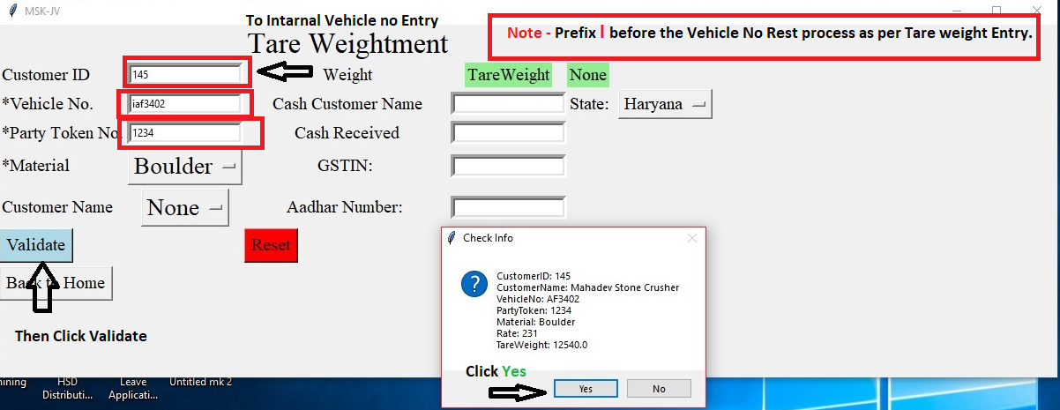

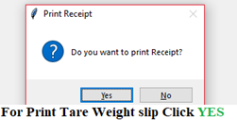

**Gross Weight/Check-out Entry**

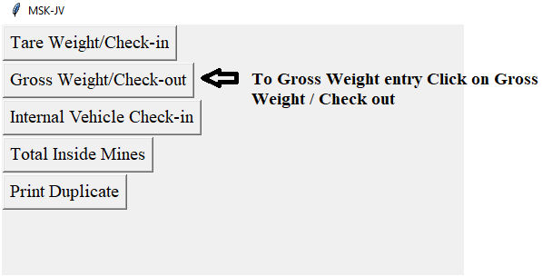

**Fill any one –Tare Receipt No or Party Token No**

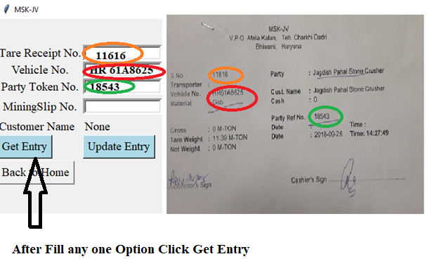

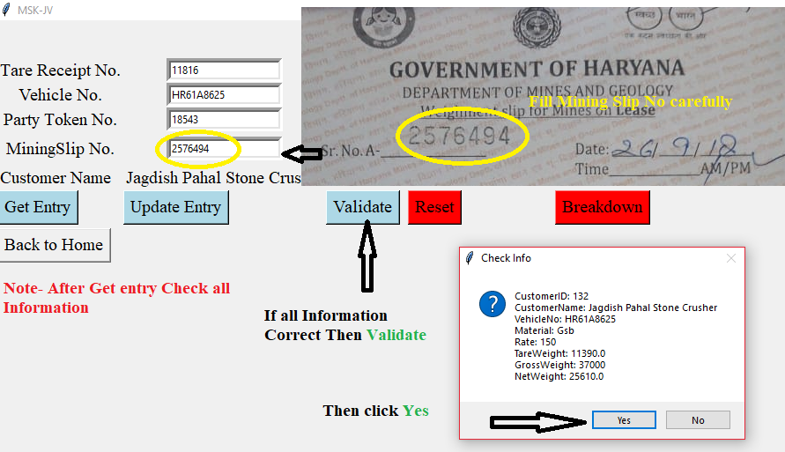

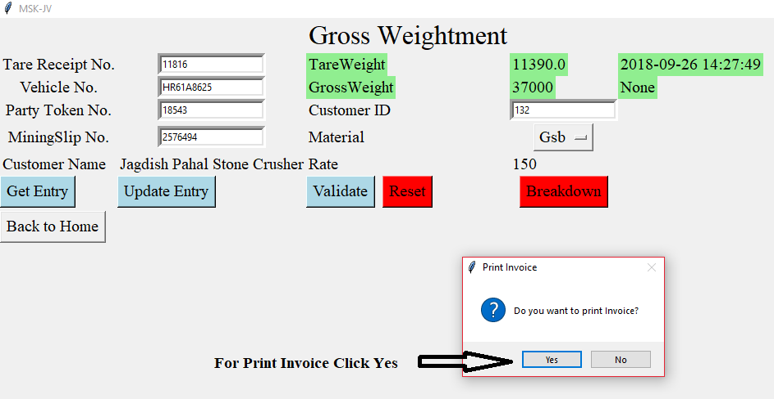

**Gross Weight Entry Complete**

**Update Entry**

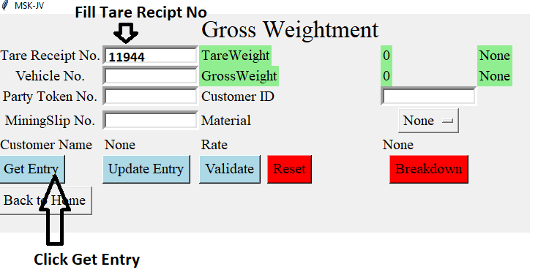

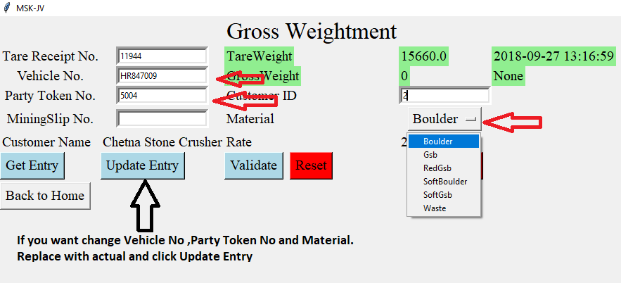

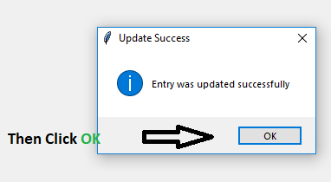

**To Cancel Inside Mines Vehicle**

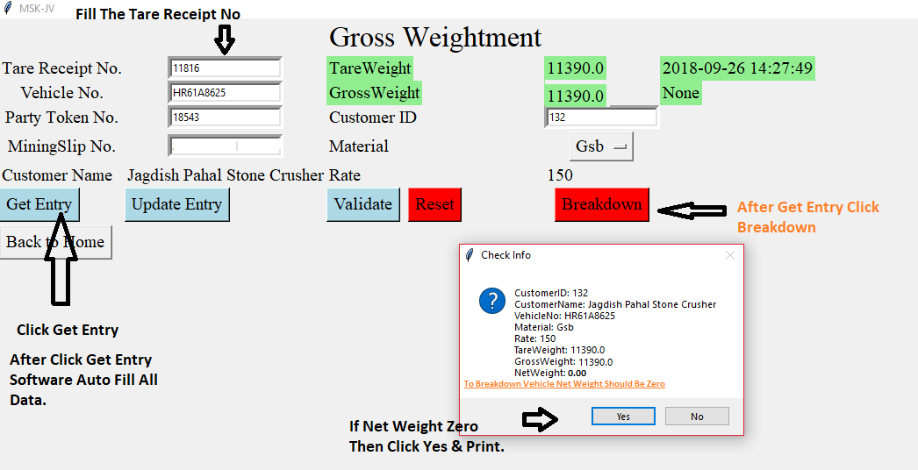

**Internal Vehicle Tare Weight Update**

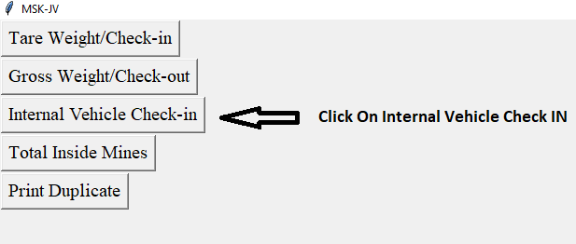

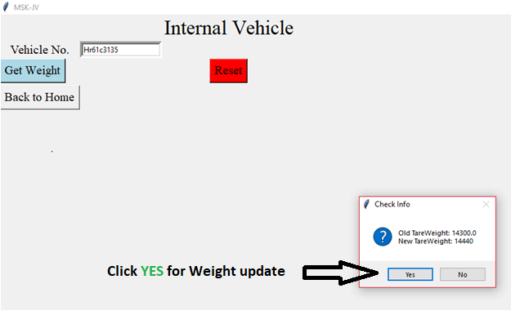

**To Check Inside Mines Vehicle**

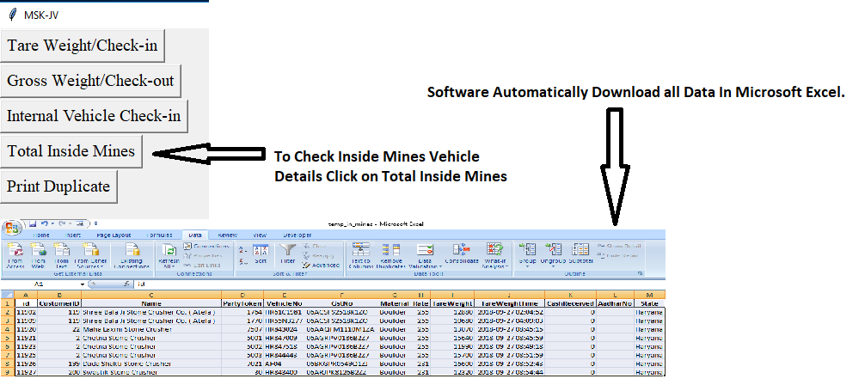

**To Download Duplicate Print**

